Process to add new page layout

Definition
A layout is implemented thru css and html. There are 7 pre-defined layouts. More will be added:
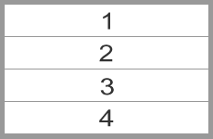 Full-Width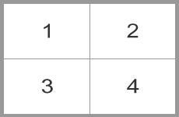Two-Columns 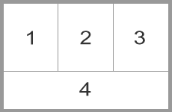Three Columns 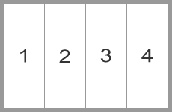Four Columns 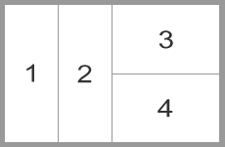Multi-Columns1
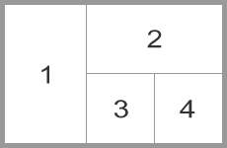Multi-Columns2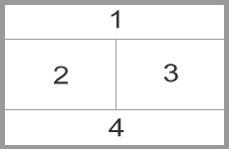Multi-Columns3 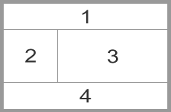Multi-Columns4
Steps
- Define unique layout var name. Follow instructions.
- Public Folders
  - Modify /class/class_page_layout.php . The template is based on a grid system that uses 16 columns.
  - Edit /css/grid.css if necessary.
  - Add layout name into db table -> @ RED_Layouts. Add width and heights of images and videos if needed.

